Columbine High School Massacre
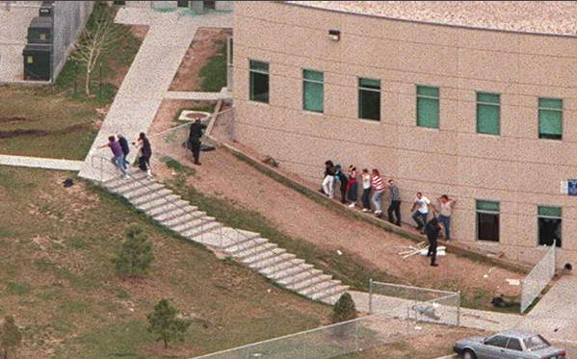
Read the text at: http://en.wikipedia.org/wiki/Columbine_High_School_massacre



Your assignment is to make talk show, which tells us briefly about the incident and then tells us about the background of Harris and Klebold. Remember to bring in experts like parents, teachers or psychiatrists
