Columbine High School Massacre
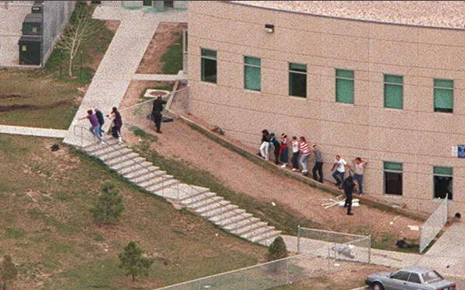

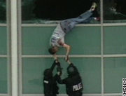

Your assignment is to make a PowerPoint presentation of the incident, taking us through the entire day. I expect you to tell and show us where the different incidents took place, who were there and what happened.
