Exercise 1
Find 10 keywords describing these 4 people and their terrible experiences.
Steve Mosiello | Genelle Guzman | Damian Vancleaf | Roger McMillen

Exercise 2
Divide the 4 above-mentioned persons between the members of your team and then by means of the keywords in exercise 1 each student is to retell the story of that person.

Exercise 3
Vocabulary – learn the meaning of the following words from the text by forming a sentence with each of them
1 | rivets
2 | rig
3 | blazed
4 | billowing
5 | vacate
6 | debris
7 | makeshift command post
8 | retrieve
9 | dime
10 | parkways
11 | pinned
12 | eerie
13 | dusk
14 | rubble
15 | notification
16 | distorted
17 | procession
18 | brace
19 | undergo
20 | grueling
21 | disturbed
22 | legacy

Exercise 4
We use adjectives to describe what we see, hear or feel. Find five adjectives used by the survivors. – try to find adjectives that you either didn’t know before or just really like.
Examples of adjectives from the text: the loud drone, a huge ball of fire

Exercise 5
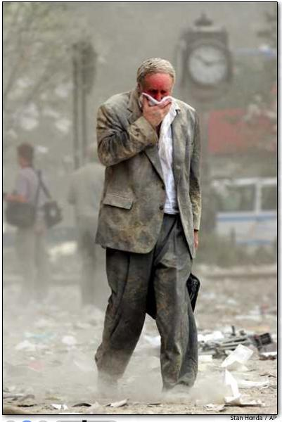
Here are some pictures from that Tuesday morning – pic one of them and tell the others in your group what you feel when you look at the picture
